Association between CD8+ tumor infiltrating lymphocytes and the clinical outcome of patients with operable breast cancer treated with adjuvant dose-dense chemotherapy. A 10 - year follow up report of a Hellenic Cooperative Oncology Group observational study.
Nikolaos Spathas et al
Supplementary Materials
Supplemental Figure 1. Distribution of sCD8, iCD8 and total CD8.
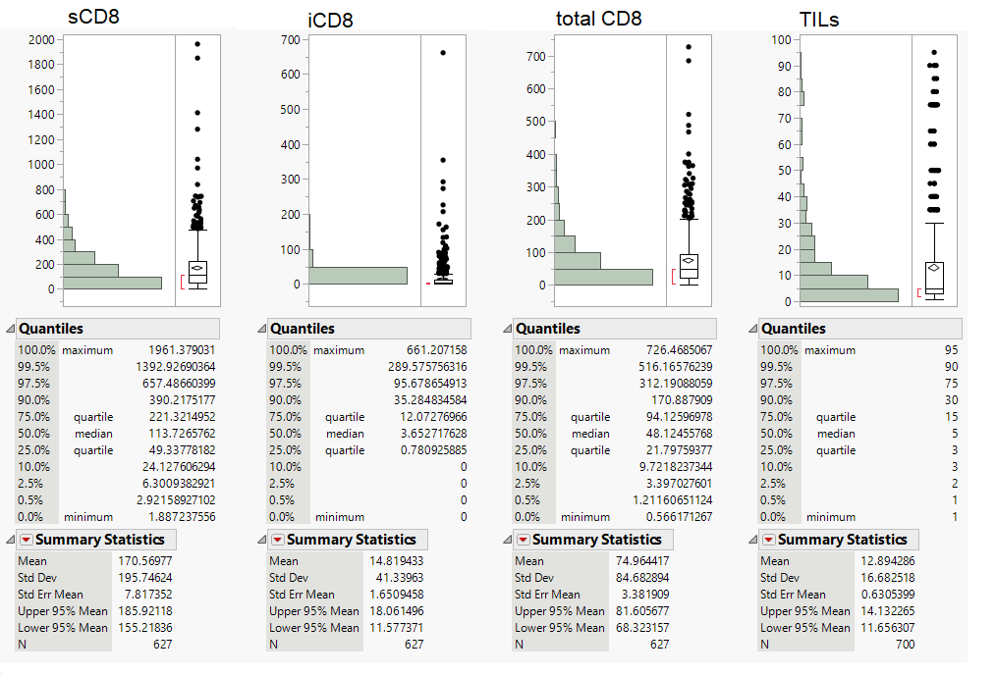
Supplemental Table 1. Staining protocols and manufacturers for IHC markers. ER1:citric acid-pH6, ER2: EDTA- pH 9, enz2: Proteinase K, RT: Room Temperature
IHC Abs | Clone/code | Manufacturer | staining protocol
ER | Clone 6F11, code NCL-L-ER-6F11 | Novocastra, Leica Biosystems Newcastle Upon Tune, UK | Antigen retrieval-20'ER1, Antibody dilution-1:70-20-RT', Bond Refine Detection kit protocol
PgR | Clone 1A6, code NCL-L-PGR | Novocastra, Leica Biosystems Newcastle Upon Tune, UK | Antigen retrieval-20'ER1, Antibody dilution-1:70-20'-RT, Bond Refine Detection kit protocol
HER2 | polyclonal, Code A 0485 | DAKO, Glostrup, DK | Antigen retrieval-20'ER1, Antibody dilution-1:500-30'-RT, Bond Refine Detection kit protocol
Ki 67 | Clone MIB-1, code M 7240 | DAKO, Glostrup, DK | Antigen retrieval-20'ER2, Antibody dilution- 1:70-20'-RT, Bond Refine Detection kit protocol
CK5 | Clone XM26, code NCL-L-CK5 | Novocastra, Leica Biosystems Newcastle Upon Tune, UK | Antigen retrieval-20'ER2, Antibody dilution- 1:50-20'-RT, Bond Refine Detection kit protocol
CD8 | Clone C8-144B, code M7103 | DAKO, Glostrup, DK | Antigen retrieval-20'ER2, Antibody dilution- 1:80-20'-RT, Bond Refine Detection kit protocol
EGFR | Clone 31G7, code 28-005 | Invitrogen Corporation, USA | Antigen retrieval -enz2-8', Antibody dilution-1:50-20'RT, Bond Refine Detection kit protocol

Supplemental Table 2. Association of iCD8, sCD8 and tCD8 with selected clinicopathological parameters of interest.
 | iCD8 |  |  |  | sCD8 |  |  | tCD8
 | Low* |  | High* | p-value | Low* | High* | p-value | Low* | High* | p-value
Age at diagnosis (years) | 54.4(29.2,82.7) |  | 52.1(29.0,75.4) | 0.085 | 53.2(29.0,82.7) | 53.8(30.2,75.4) | 0.71 | 54.1(29.0,82.7) | 52.7(30.7,76.8) | 0.15
Ki67 | 27.0(0.00,100.0) |  | 60.0(0.00,100.0) | <0.001 | 28.0(0.00,100.0) | 48.0(0.00,100.0) | <0.001 | 28.0(0.00,100.0) | 55.0(0.00,100.0) | <0.001
TILs | 5.0(1.00,65.0) |  | 20.0(2.0,90.0) | <0.001 | 5.0(1.00,80.0) | 20.0(2.0,90.0) | <0.001 | 5.0(1.00,80.0) | 20.0(2.0,90.0) | <0.001
Menopausal status |  |  |  | 0.17 |  |  | 0.90 |  |  | 0.54
Premenopausal | 200(42.5) |  | 76(48.7) |  | 208(44.2) | 68(43.6) |  | 204(43.3) | 72(46.2)
Postmenopausal | 271(57.5) |  | 80(51.3) |  | 263(55.8) | 88(56.4) |  | 267(56.7) | 84(53.8)
Breast surgery |  |  |  | 0.32 |  |  | 0.76 |  |  | 0.22
Modified radical | 257(54.6) |  | 78(50.0) |  | 250(53.1) | 85(54.5) |  | 245(52.0) | 90(57.7)
Partial mastectomy | 214(45.4) |  | 78(50.0) |  | 221(46.9) | 71(45.5) |  | 226(48.0) | 66(42.3)
Tumor size |  |  |  | 0.82 |  |  | 0.44 |  |  | 0.65
≤2 cm | 177(37.6) |  | 62(39.7) |  | 185(39.3) | 54(34.6) |  | 184(39.1) | 55(35.3)
2.1-5 cm | 258(54.8) |  | 84(53.8) |  | 250(53.1) | 92(59.0) |  | 254(53.9) | 88(56.4)
>5 cm | 36(7.6) |  | 10(6.4) |  | 36(7.6) | 10(6.4) |  | 33(7.0) | 13(8.3)
Nodal status |  |  |  | 0.61 |  |  | 0.97 |  |  | 0.48
0-3 | 329(70.3) |  | 113(72.4) |  | 332(70.8) | 110(71.0) |  | 328(70.1) | 114(73.1)
≥4 | 139(29.7) |  | 43(27.6) |  | 137(29.2) | 45(29.0) |  | 140(29.9) | 42(26.9)
Grade |  |  |  | <0.001 |  |  | <0.001 |  |  | <0.001
I-II | 279(59.2) |  | 57(36.5) |  | 277(58.8) | 59(37.8) |  | 273(58.0) | 63(40.4)
III | 192(40.8) |  | 99(63.5) |  | 194(41.2) | 97(62.2) |  | 198(42.0) | 93(59.6)
ER/PgR status (central assessment) |  |  |  | <0.001 |  |  | <0.001 |  |  | <0.001
Positive | 371(85.5) |  | 107(73.3) |  | 375(85.4) | 103(73.0) |  | 373(85.6) | 105(72.9)
Negative | 63(14.5) |  | 39(26.7) |  | 64(14.6) | 38(27.0) |  | 63(14.4) | 39(27.1)
HER2 status (central assessment) |  |  |  | 0.95 |  |  | 0.16 |  |  | 0.16
Positive | 83(17.7) |  | 27(17.4) |  | 77(16.4) | 33(21.3) |  | 77(16.4) | 33(21.3)
Negative | 387(82.3) |  | 128(82.6) |  | 393(83.6) | 122(78.7) |  | 393(83.6) | 122(78.7)
*These values represent median (m), range

Supplemental Table 3. Sites of relapse in the entire cohort of patients.
 | Total cohort (N=979)
 | N (%)
Locoregional relapse | 19(1.9)
Axillary nodes | 6(0.6)
Supraclavicular nodes | 4(0.4)
Skin | 5(0.5)
Residual breast | 5(0.5)
Distant relapse | 151(15.4)
Brain | 27(2.8)
Bones | 76(7.8)
Lung/Pleura | 37(3.8)
Liver | 50(5.1)
Nodes | 20(2.0)
Skin | 1(0.1)
Contralateral breast | 6(0.6)
Adrenal | 1(0.1)
Peritoneal implants | 1(0.1)
Cervix | 1(0.1)
Abdomen | 1(0.1)
Kidney | 1(0.1)
*Six patients had both locoregional and distant relapse.

Supplemental Table 4. Association of clinicopathological parameters of interest with patients’ outcome.
Parameter | Event/Total | HR (95% CI) | p-value | Event/Total | HR (95% CI) | p-value
 | DFS |  |  | OS
Age |  | 1.02 (1.00-1.03) | 0.002 |  | 1.03 (1.01-1.04) | <.001
Menopausal status
Postmenopausal | 163/564 | 1.34 (1.04-1.73) | 0.026 | 132/564 | 1.44 (1.08-1.93) | 0.014
Premenopausal | 90/415 | Reference | -- | 69/415 | Reference | --
Breast surgery
Modified radical | 165/545 | 1.60 (1.24-2.08) | <.001 | 133/545 | 1.65 (1.23-2.21) | <.001
Partial mastectomy | 88/434 | Reference | -- | 68/434 | Reference | --
Tumor size
>5 cm | 28/77 | 2.21 (1.43-3.41) | <.001 | 24/77 | 2.56 (1.58-4.13) | <.001
2.1-5 cm | 149/506 | 1.62 (1.23-2.13) | <.001 | 122/506 | 1.82 (1.32-2.50) | <.001
≤2 cm | 76/395 | Reference | -- | 55/395 | Reference | --
Nodal status
≥4 | 118/294 | 2.44 (1.90-3.12) | <.001 | 101/294 | 2.79 (2.12-3.69) | <.001
0-3 | 133/681 | Reference | -- | 98/681 | Reference | --
Adjuvant HT
Yes | 182/721 | 0.85 (0.65-1.13) | 0.27 | 141/721 | 0.78 (0.58-1.07) | 0.12
No | 69/251 | Reference | -- | 58/251 | Reference | --
Adjuvant RT
Yes | 191/708 | 1.24 (0.92-1.66) | 0.16 | 156/708 | 1.43 (1.01-2.01) | 0.043
No | 58/259 | Reference | -- | 41/259 | Reference | --
Grade
I-II | 129/526 | 0.84 (0.66-1.08) | 0.18 | 97/526 | 0.76 (0.58-1.01) | 0.056
III | 124/452 | Reference | -- | 104/452 | Reference | --
ER/PgR status (central assessment)
Positive | 137/534 | 1.34 (0.84-2.12) | 0.22 | 110/534 | 1.17 (0.72-1.90) | 0.53
Negative | 21/109 | Reference | -- | 19/109 | Reference | --
HER2 status (central assessment)
Positive | 22/121 | 0.66 (0.43-1.04) | 0.073 | 20/121 | 0.76 (0.47-1.22) | 0.26
Negative | 154/575 | Reference | -- | 125/575 | Reference | --

HR, hazard ratio; CI, confidence interval

Supplemental Table 5. Association of sCD8, iCD8 and total CD8 with DFS and OS in the entire cohort of patients and among patients with luminal B tumors.

Parameter | Event/Total | HR (95% CI) | p-value | Event/Total | HR (95% CI) | p-value
 | DFS |  |  | OS
 | Entire cohort
sTILs^ |  | 0.94 (0.85-1.04) | 0.23 |  | 0.96 (0.86-1.07) | 0.41
iCD8
High | 27/156 | 0.58 (0.39-0.88) | 0.011 | 23/156 | 0.63 (0.40-0.98) | 0.043
Low | 133/471 | Reference | -- | 106/471 | Reference | --
sCD8
High | 31/156 | 0.70 (0.47-1.03) | 0.070 | 26/156 | 0.73 (0.48-1.13) | 0.16
Low | 129/471 | Reference | -- | 103/471 | Reference | --
tCD8
High | 30/156 | 0.65 (0.44-0.97) | 0.034 | 22/156 | 0.58 (0.37-0.92) | 0.020
Low | 130/471 | Reference | -- | 107/471 | Reference | --
 | Luminal B
sTILs^ |  | 1.00 (0.85-1.17) | 0.95 |  | 1.03 (0.87-1.22) | 0.74
iCD8
High | 16/68 | 0.74 (0.42-1.30) | 0.30 | 14/68 | 0.78 (0.43-1.42) | 0.41
Low | 54/176 | Reference | -- | 45/176 | Reference | --
sCD8
High | 14/62 | 0.70 (0.39-1.25) | 0.23 | 12/62 | 0.70 (0.37-1.32) | 0.27
Low | 56/182 | Reference | -- | 47/182 | Reference | --
tCD8
High | 12/60 | 0.59 (0.32-1.10) | 0.098 | 10/60 | 0.58 (0.29-1.14) | 0.12
Low | 58/184 | Reference | -- | 49/184 | Reference | --

HR, hazard ratio; CI, confidence interval
^10% increments

